A Lent / Reconciliation Liturgy

THE GATHERING OF THE COMMUNITY

Confession
The liturgy commission suggests starting the Lenten service with a penitential tone. This could either be in silence, or with a silent procession, followed by Confession and Absolution in this, or another form.

Call to Confession
Dear Friends in Christ, we gather this day on the ancestral territories of the Kwakwaka’wakw, Nuu-chah-nulth and Coast Salish peoples with whom we are on a sacred journey of truth telling, reconciliation and healing. We gather recognizing that this sacred journey is one we live into as individuals and as communities. In love we are called to be co-creators with God, to be truth-tellers, reconcilers and healers, but our failures and shortcomings often leave us keenly aware of what seems an unbridgeable distance from the mystery and the promise of holy relationship.

In Christ, God bridges this distance and reaches out to us across time and space.
The season of Lent, invites us to reflect on those places in us that are broken; places where we are in need of God’s love poured out. We are called to reflect on those places in our relationships and our communities where there is brokenness and a need for God’s reconciling love. And we are called to reflect on our world and the places where there is brokenness and a need for a new and right relationship. As we reflect, we do so with contrite but hopeful hearts, trusting in God’s steadfast love and infinite mercy.
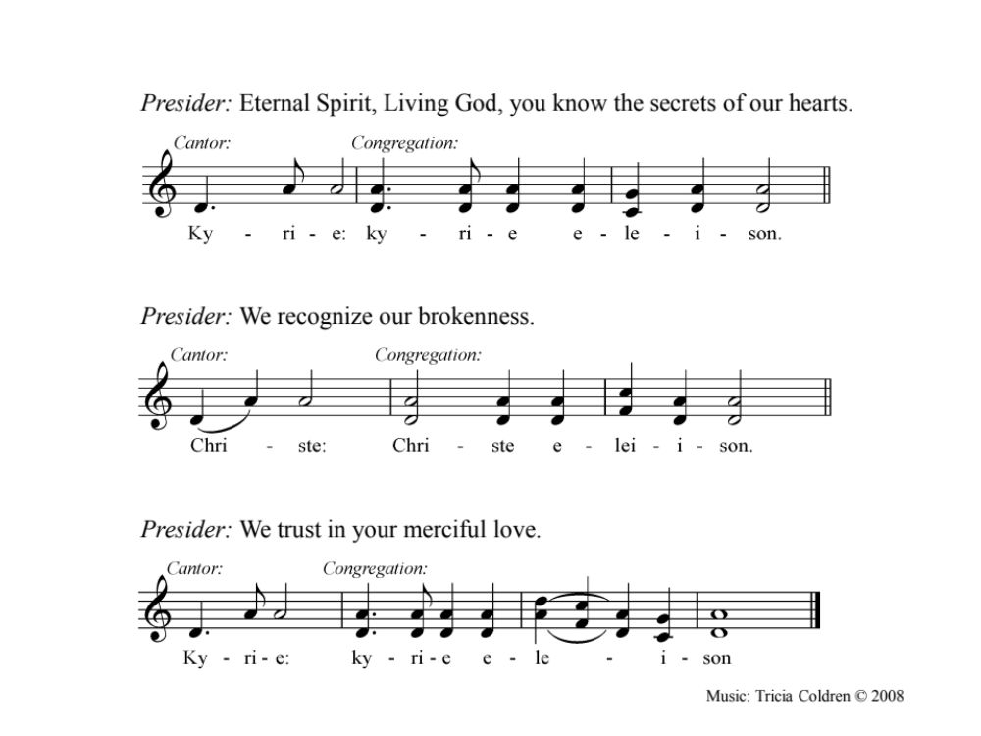

Confession and Absolution (BAS)
Most merciful God, we confess that we have sinned against you
in thought, word, and deed, by what we have done
and by what we have left undone.
We have not loved you with our whole heart;
we have not loved our neighbours as ourselves.
We are truly sorry and we humbly repent.
For the sake of your Son Jesus Christ,
have mercy on us and forgive us,
that we may delight in your will,
and walk in your ways,
to the glory of your name. Amen.

Absolution
Almighty God have mercy upon you,
pardon and deliver you from all your sins,
confirm and strengthen you in all goodness,
and keep you in eternal life;
through Jesus Christ our Lord.
Amen.

Trisagion (sung)

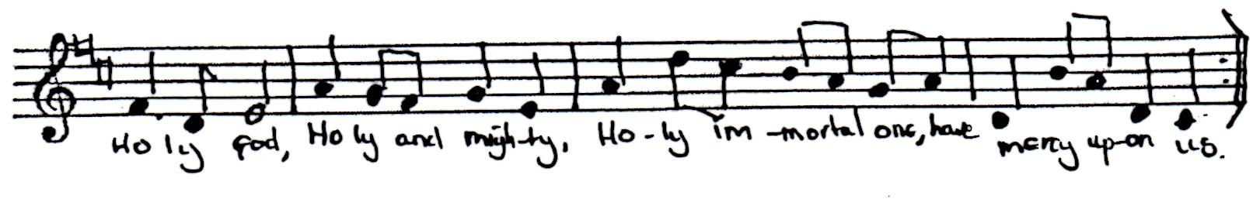
Collect for Reconciliation
This collect may be used in addition to the Collect of the Day (BAS 286-295) or other Collects. There are additional collects provided in Appendix A.

O God, by your Word you marvellously carry out the work of reconciliation:
Grant that in our Lenten fast
we may be devoted to you with all our hearts,
and united with one another in prayer and holy love;
through Jesus Christ our Lord,
who lives and reigns with you and the Holy Spirit,
one God, for ever and ever.
Amen.
- Rivendell Community, Episcopal Church USA

THE PROCLAMATION OF THE WORD

Readings

Sermon

Silence

The Creed
The Apostles’ or Nicene Creeds are suggested, or there are alternate Affirmations of Faith provided in Appendix D or in the BAS.

The Prayers of the People
There is a litany provided here. Alternately, the Lenten prayers in the BAS page 121 may be used. Other prayers are included in Appendix B. For any of these prayers, we encourage periods of silence as appropriate in the settings that they are used.

A Litany of Reconciliation by Aboriginal Peoples of Canada
Creator, we long for wholeness in our church. For honest, open communications. To say what we need to say, in safety and without fear.
Hear our Prayer, O God, and in your love, answer.

Creator, help us to stay close, to never let go of one another, in joy as well as in pain. To embrace, to feel the physical presence of one another, and to be truly present, one to another.
Hear our Prayer, O God, and in your love, answer.

Creator, we need to feel connected to our families, and to the church family. To learn and to grow. To be part of a web of relationships. To pass on values, love and a sense of closeness. To be part of an inner circle of safety. To spiral out to an open circle that welcomes others in.
Hear our Prayer, O God, and in your love, answer.

Creator, we long for a gentle time of warmth and wholeness. For time and energy to nourish relationships. For honest sharing out of genuine love for all members of the church community.
Hear our Prayer, O God, and in your love, answer.

Creator, at this time, we pray for the needs of our local community. (Prayers for the sick, our neighbourhood, those preparing for baptism, reception or reaffirmation, etc. If appropriate, silence may be offered for people to name their needs and the needs of others).
Hear our Prayer, O God, and in your love, answer.

Creator, we long to dance. To move into the centre of the circle. To touch and grow together in community into completeness.
Hear our Prayer, O God, and in your love, answer.
- Worship in the Vision of the New Agape, The Anglican Church of Canada (2004)

THE CELEBRATION OF THE EUCHARIST

Prayer Over the Gifts
Additional prayers over the gifts may be found in Appendix C.

Presider: Holy One, we raise our hearts and voices in thanksgiving for all the good gifts of your creation that send your promise of new life. Holy One, we give you thanks for the gift of your son, Jesus, who reconciles us to you and to each other. We give you thanks for the Holy Spirit, who draws us together and helps us in our walk with Jesus. May we honour you and each other in receiving these gifts, by using them in service to you and our neighbours.
Thanks be to God . Amen

The Great Thanksgiving

Eucharistic Preface
The following preface may be used – or the Lenten preface on BAS 220.
It is right to give you thanks and praise. Worship and praise belong to you, maker of light and darkness. Your wisdom draws beauty from chaos, brings a harvest out of sorrow and leads the exiles home. In Christ enemies are reconciled, debts forgiven and strangers made welcome .

Your Spirit frees us to live as sons and daughters in your creation. We who by Christ's power follow the way of the Cross, sharing the joy of his obedience, now offer you our praise, with angels and archangels and the whole company of heaven singing the hymn of your unending glory: (The Church of Scotland)

Please use one of the Eucharistic Prayers from the Liturgy of the Islands or whichever prayer is most appropriate to your specific context from the BCP / BAS

The Breaking of the Bread
The following fraction sentences may be used – or see BAS 213 or Appendix E for additional fractions.

He whose cross is a sign of hope for many
Is now present in this bread.
He whose death brings healing to our world
Is now present in this wine.
Here is Christ coming to us in bread and wine.

Prayer after Communion
God of compassion,
Through your Son Jesus Christ you reconciled your people to yourself. Following his example of prayer and fasting, may we obey you with willing hearts and serve one another in holy love; through Jesus Christ our Lord. Amen.

Blessing
The love of the faithful Creator,
the peace of the wounded Healer,
the joy of the challenging Spirit,
The hope of the three in One
surround and encourage you
on your sacred journey, today,
tonight and forevermore.
- adapted from the Pattern of Days ed. by Kathy Galloway

Dismissal
Let us bless God, our merciful Creator,
Thanks be to God. Amen.

Appendix A: Additional Collects

ADDITIONAL COLLECT 1
O God who reconciles light and darkness, night and day, help us to be bearers of your reconciling love in all the places where we encounter contrast, disagreement and discord. Strengthen, uphold and inspire our work towards reconciliation with those from whom we are divided, and our solidarity with those who suffer. Amen.

ADDITIONAL COLLECT 2
Creator
we give you thanks for all you are
and all you bring to us for our visit within your creation.
In Jesus, you place the Gospel in the Centre of this Sacred Circle
through all of which all creation is related.
You show us the way to live a generous and compassionate life.
Give us your strength to live together
with respect and commitment
as we grow in your Spirit,
for you are God,
now and forever.
Amen.
- Anglican Council of Indigenous Peoples / Disciples Prayer Book

ADDITIONAL COLLECT 3
Creator God,
from you every family in heaven and on earth takes its name.
You have rooted and grounded us in your covenant love,
and empowered us by your Spirit
to speak the truth in love,
and to walk in your way towards justice and wholeness.
Mercifully grant that your people,
journeying together in partnership,
may be strengthened and guided
to help one another
to grow into the full stature of Christ,
who is our light and our life.
Amen.
—Indigenous Ministries, Anglican Church of Canada

ADDITIONAL COLLECT 4
God of unbounded grace,
you declare the power of your reconciling love
in the death and resurrection of our Saviour Jesus Christ.
Teach us, who live only in your forgiveness,
to forgive one another;
heal our divisions and cast out our fears;
through Jesus Christ your Son our Lord,
who is alive and reigns with you,
in the unity of the Holy Spirit,
one God, now and for ever.
Amen
- The Church of England

Appendix B: Additional Prayers of the People

Additional Prayer 1: A Four Directions Prayer for Reconciliation
The people may face the four directions as these prayers are said in various voices.

East: We come to you, O God, as a few of your many children on this earth. We thank you for the gift of life that comes to us like the dawn of each new day. We pray for light on our path. Open our hearts to your Spirit. WE also remember your people who live to the east of us on this earth. Bring peace where there is constant fighting, and freedom where there is coercion, so that people may welcome the daylight with joy rather than fear.

South: We humbly thank you, God, giver of life, for the abundance and variety of your creation. We thank you for the warm winds of the south that allow plants and food to grow, year after year. Give that we may learn the lessons hidden under every leaf and rock. We pray today for the many peoples of the south who do not have enough to eat. Help us always to be generous with what we have an share with those who have less. We pray, too, that you will bring healing where there is strife and brokenness. Give to the powerful a change of heart, and to those who suffer, courage and the ability to forgive. Where there is death and hatred, sow the seeds to new life.

West: Lord, we thank you for the beauty of the red and purple sunset. By it teach us respect for all the things you have made. Renew our understanding day by day as we travel along our own road through life. And give us insight today that will serve us long after we leave this gathering. We thank you for the heritage you have bestowed on this country through the generations who lived here long before the Europeans came to settle. Open our ears to the wisdom of Indigenous peoples. Help us to share with gratitude the unique gifts you have bestowed on every nation. Bring healing also, we pray, to the many Indigenous communities who suffer because of what a greedy and insensitive culture has done, often in your name. By your Spirit, bring reconciliation between our cultures so we may walk together before you.

North: We thank you, O God, for our Saviour Jesus Christ, whose sacrifice makes us pure as the snow. We all depend on your forgiveness and grace. We ask it for ourselves and for our nation. Give us courage to ask forgiveness when we have been wronged. Send wisdom along with the white hairs of our elders. Teach us to listen when you speak through them. And help us as sisters and brothers to mature in our faith and our understanding of the Gospel. Make us ever ready to come to you with clean hands and straight hearts.

We Worship That Way, Council of Christian Reformed Churches in Canada (cited in New Agape, Anglican Church of Canada)
Additional Prayer 2: Prayers For Healing and Hope
Let us come together now in prayer, recognizing brokenness suffered,
wounds not yet healed, and our hope for peace and restoration.

Pause / silence

O Great Spirit, God of all people and every tribe,
through whom all people are related;
Call us to the kinship of all your people.
Grant us vision to see through the lens of justice,
the brokenness of the past;

<Open Space prayers of lament for the brokenness of the past.>
In your great love, O God,
Hear our prayers.

Help us to listen to you and to one-another,
in order to heal the wounds of the present;
And give us courage, patience, and wisdom to work together
for healing and hope with all of your people,
now and in the future.

<Open Space prayers for healing and restoration>
In your great love, O God,
Hear our prayers.

Mend the hoop of our hearts and let us live in justice and peace
through Jesus Christ our Lord,
the One who comes to all people that we might live in dignity.
Amen.

- adapted from the Episcopal Church: Resources on the Doctrine of Discovery

The following unison prayers may be used in liturgical settings, or handed out or printed as devotional prayers.

Additional Prayer 3
Lord Jesus Christ, you are the way of peace.
Come into the brokenness of our lives and our land with your healing
love. Help us to be willing to bow before you in true repentance and to
bow to one another in real forgiveness.
By the fire of your Holy Spirit, melt our hard hearts and consume the
pride and prejudice with separate us.
Fill us, O Lord, with your perfect love which casts out fear and bind us
together in that unity which we share with the Father and the Holy Spirit.
Amen
- South African Council of Churches

Additional Prayer 4
Almighty God, long-suffering and of great goodness: We confess to thee, we confess with our whole heart: our neglect and forgetfulness of thy commandments: our wrong doing, speaking, and thinking: the hurts we have done to others: and the good we have left undone. O God, forgive thy people that have sinned against thee: and raise us to newness of life: through Jesus Christ our Lord. Amen.
- taken from After the Third Collect (Eric Milner-White, ed.) 1959, p. 115

Additional Prayer 5 (Prayer for Brotherhood – R. Niebuhr, alt.)
Oh, God, who has ordained that all people should live and work together as brothers and sisters, remove, we humbly beseech you, from those who are at variance, all spirit of strife and all occasion for bitterness that, seeking only what is just and equal, they may ever continue in union and concord. Lead us out of the night of this conflict into this day of justice. Give us grace to be instruments of the kingdom of love and justice in the affairs of people; and patience in dealing with all the sins and selfishness of people, and humility in recognizing our own that we may judge wisely and composing their differences build them into a true community. Amen.
- edited from Harper Collins Book of Prayers (Robert Van de Weyer, ed.) 1997, p. 271

Additional Prayer 6 (A Distracted Bird – St. Therese of Lisieux)
Jesus, you have been very patient with me, and it is true that I have never strayed far from you. But I know, and you know, how often in my wretched imperfection I allow myself to be distracted, when I should be looking steadily at the sun. I am like a bird, picking up a piece of grain first on this die, then on that side, running off to catch a worm, coming across a pond and wetting its feathers there, and even having a look at some pretty flowers it passes. Since I cannot compete with the eagles I am more ready to occupy my mind with the trifles of the earth.

But, dear Jesus, after all these infidelities, I don't rush away into a corner and weep. I turn back to the sun which is the centre of my love and dry my bedraggled wings in its rays. I tell the Father all about my faults, down to the last details. I throw myself recklessly on him, as the best way to regain control of myself, and so win a greater measure of your love. After all, haven't you told us that you came to call sinners, not the righteous?
- edited from Ibid, pp. 356-357

Appendix C: Additional Prayers over the gifts

As the grain once scattered in the fields
and the grapes once dispersed on the hillside
are now reunited on this table in bread and wine,
so, may your whole Church be reconciled and gathered together
from the corners of the earth into your kingdom.
Amen.

or

Blessed are you, God of all creation:
through your goodness we have this bread to set before you,
which earth has given and human hands have made.
It will become for us the bread of life.
Blessed be God for ever.

Blessed are you, Lord God of all creation:
through your goodness we have this wine to set before you,
fruit of the vine and work of human hands.
It will become for us the cup of salvation.
Blessed be God for ever. Amen

Nourish us with this feast of abundant mercy, that we might be reconciled to you and to all of creation through you son, Jesus Christ our Lord.
Amen

Appendix D: Additional Affirmations of Faith

An Affirmation of Faith
We believe in one God, the Creator (other names may be used here)
You have made all things and placed your spirit in them.
We believe in your Son, Jesus the Christ,
Sent from your heart to preach
And change our hearts to be like yours.
He was born of Mary, his mother.
He, being Creator with you,
From the beginning of all time,
Became a man like one of us.
He suffered and died on a cross of sin.
He rose from death.
He was taken into heaven
And now sits on your right hand.
He will one day come again to the earth
To proclaim your kingdom and dominion.
We believe in a holy and great Spirit
Who comes from you to empower us
And enable us to live as your children.
He is worshipped as you are,
For he is one with You and Jesus.
We believe in one holy church,
Begun and sustained by your apostles.
We look to our baptism for forgiveness.
We believe that one day all the dead
Will be made alive in the resurrection,
And we believe that when we die
We will return to you and be judged by you. Amen.
—Worship in the New Agape, Diocese of Huron

AN AFFIRMATION OF FAITH

O God, the source of our being and the goal of all our longing,
we believe and trust in you.
The whole earth is alive with your glory
and all that has life is sustained by you.
We commit ourselves to cherish your world and to seek your face.

O God, embodied in a human life,
we believe and trust in you.
Jesus our brother, born of the woman Mary,
you confronted the proud and the powerful,
and welcomed as your friends those of no account.
Holy Wisdom of God, firstborn of creation,
you emptied yourself of power,
and became foolishness for our sake.
You laboured with us upon the cross to reconcile all the world to God,
and have brought us forth to the hope of resurrection.
We commit ourselves to struggle against evil and to choose life.

O God, life-giving Spirit, Spirit of healing and comfort,
of integrity and truth, we believe and trust in you.
rushing wind and Pentecostal fire,
we commit ourselves to work with you and renew our world.
Amen.
—2008 Women’s Theology St. Augustine by-the-Sea

Appendix E: Additional Fraction Sentence

Creator of all,
who summons the salmon
from the depths of the seas
to yearn for the place of their origin.
So may your Spirit stir in our hearts
to return and find our home in you.
- From Liturgy of the Islands

